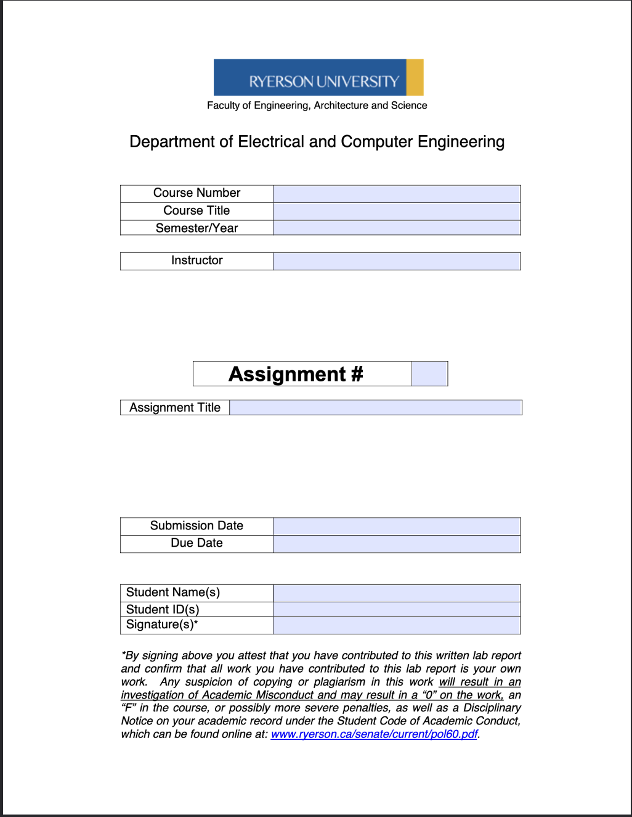
ELE504
Electronic Circuits II
F2024
Dr. Rueda
7
ELE504 Pre-Lab 7
November 30th, 2024
December 2nd, 2024
Shai Mourad
501170415
SM

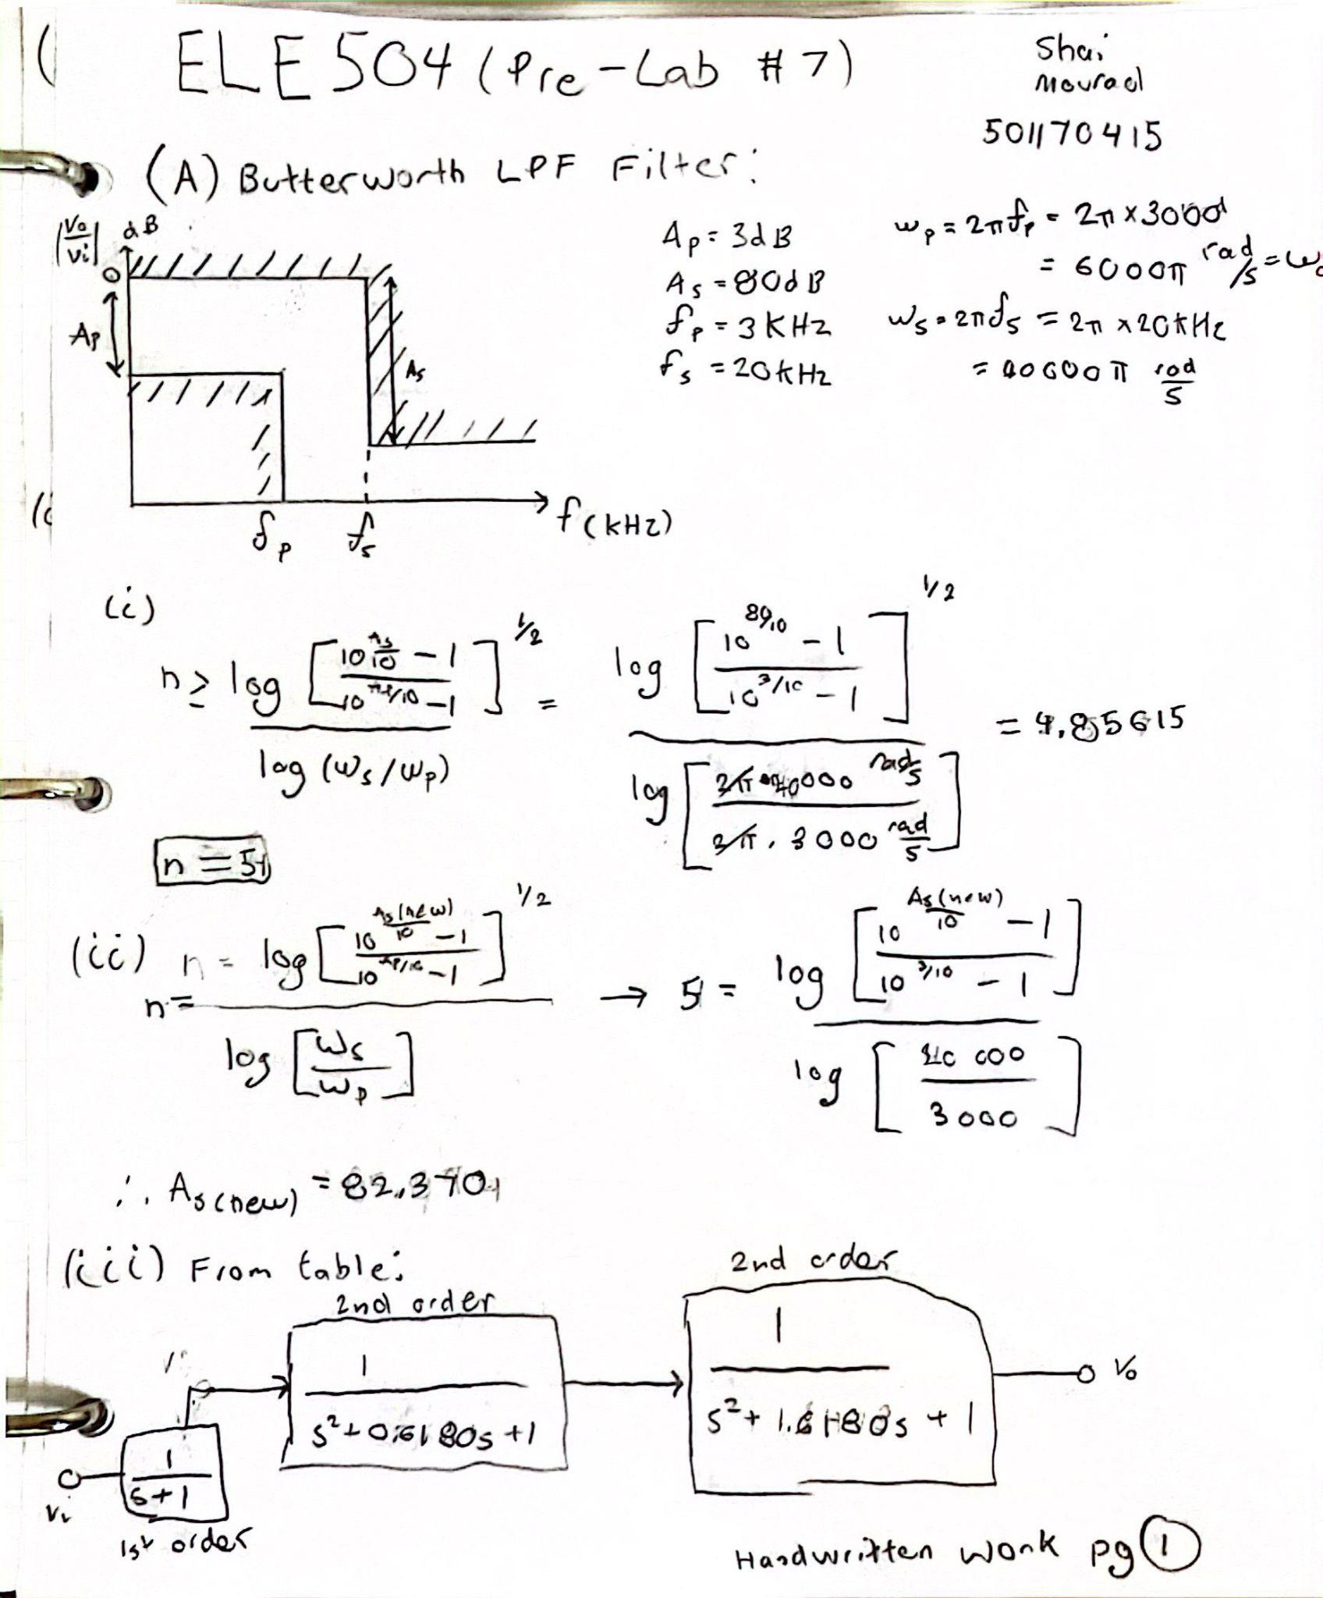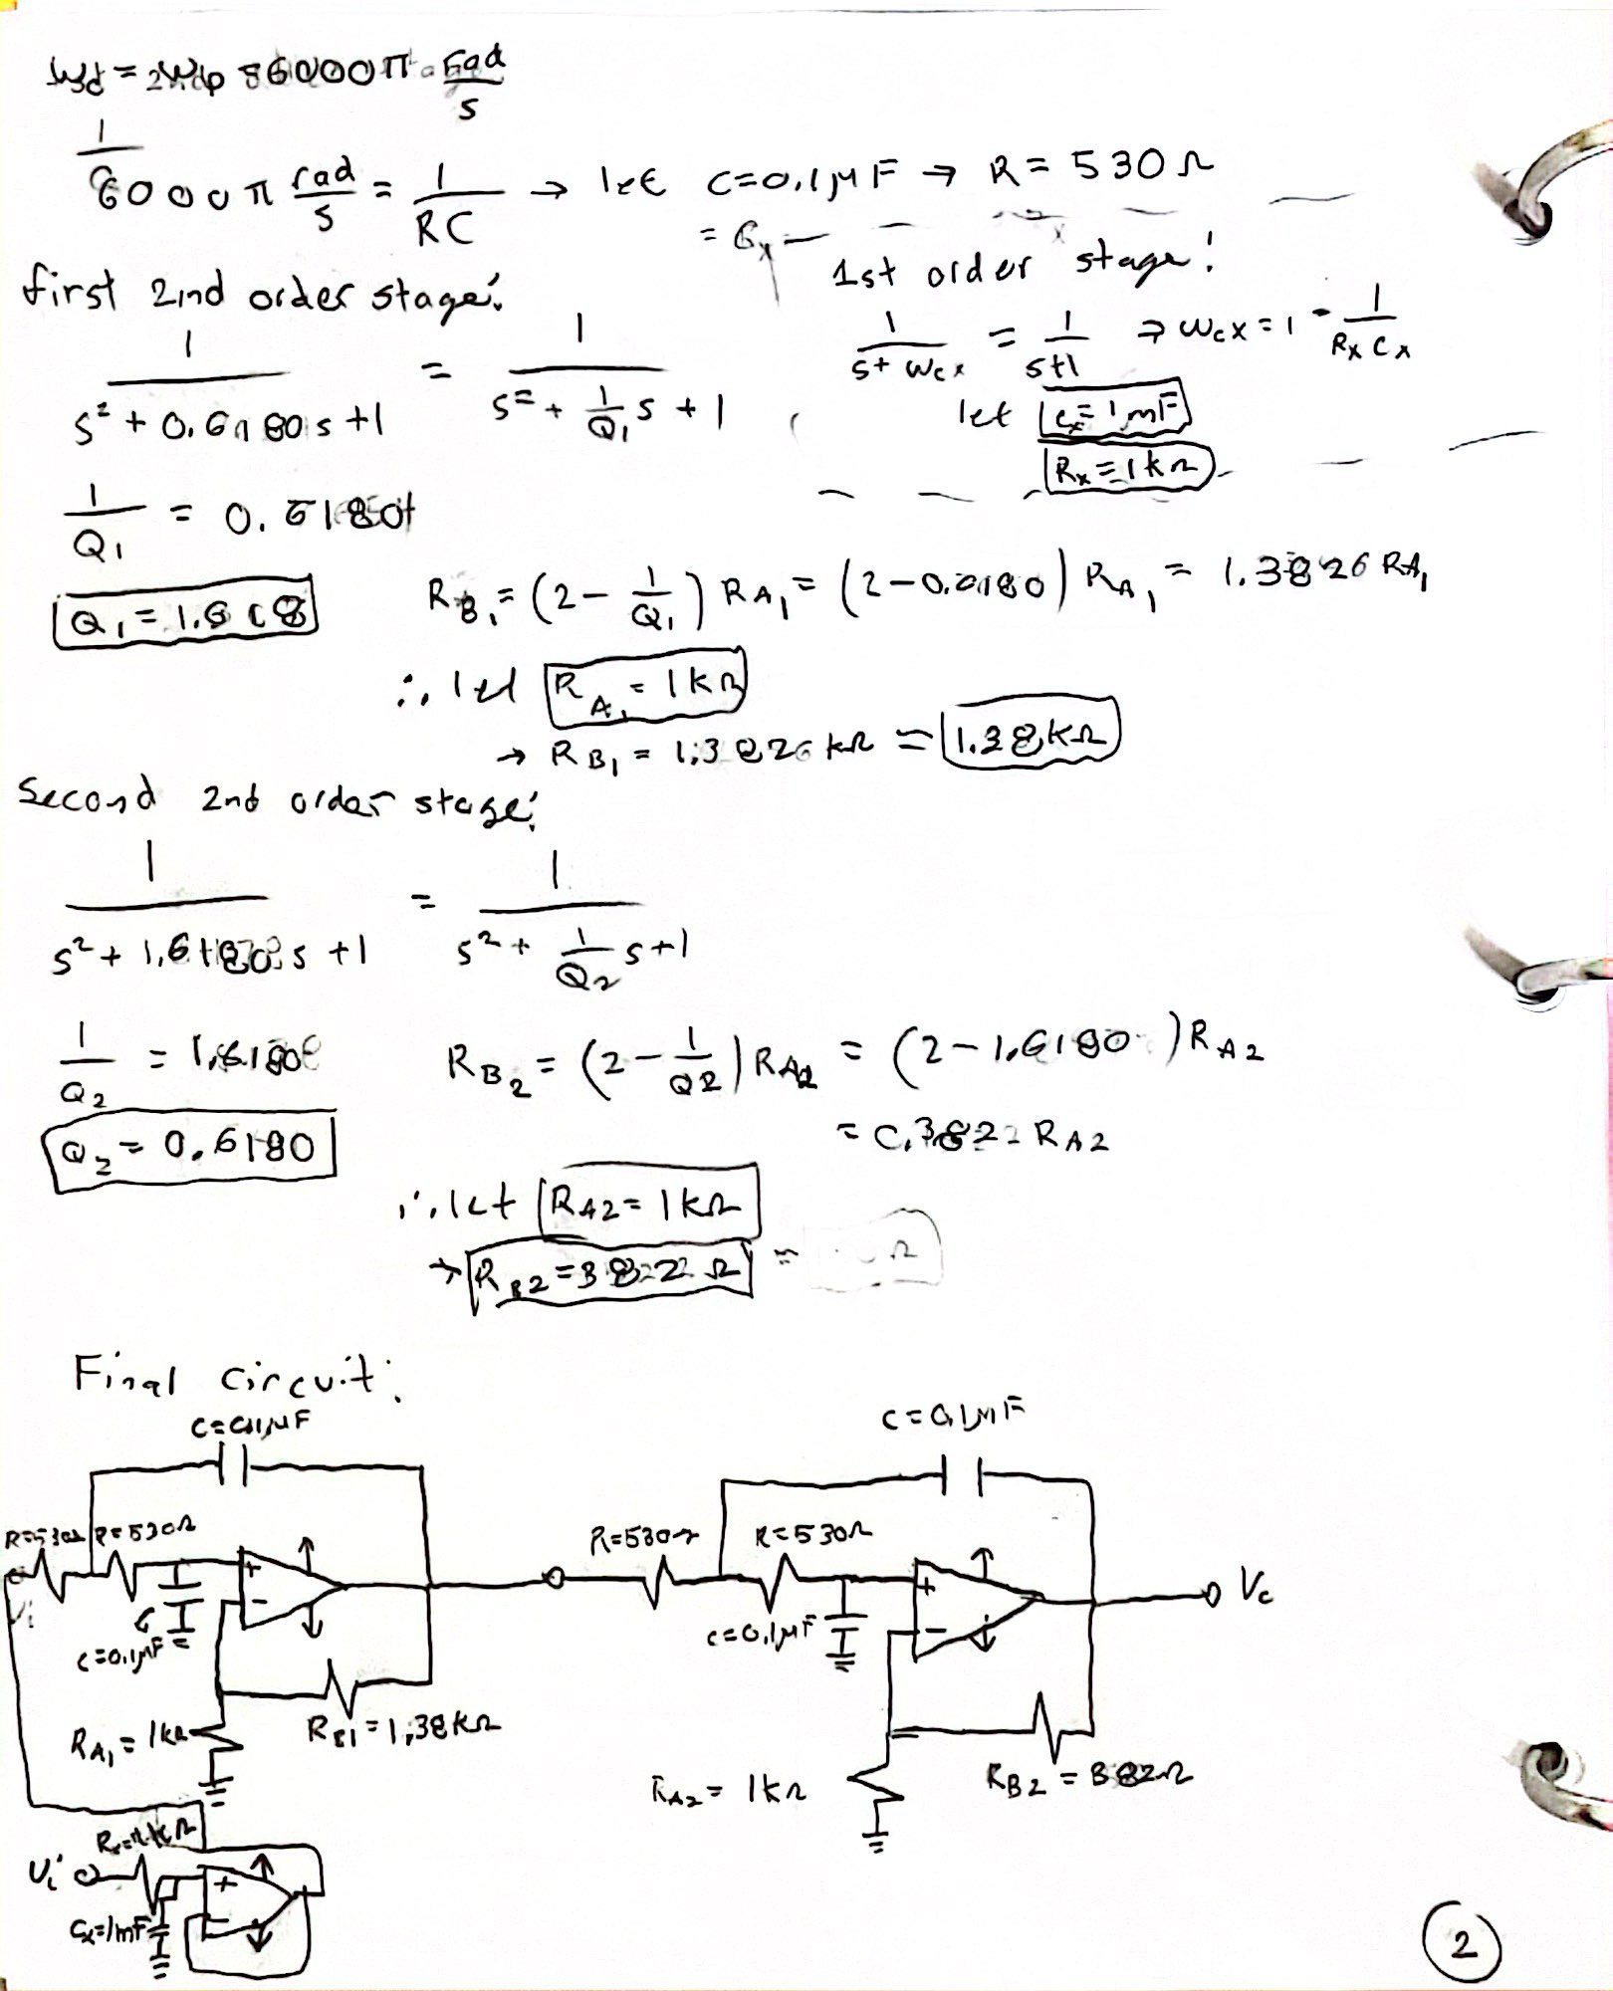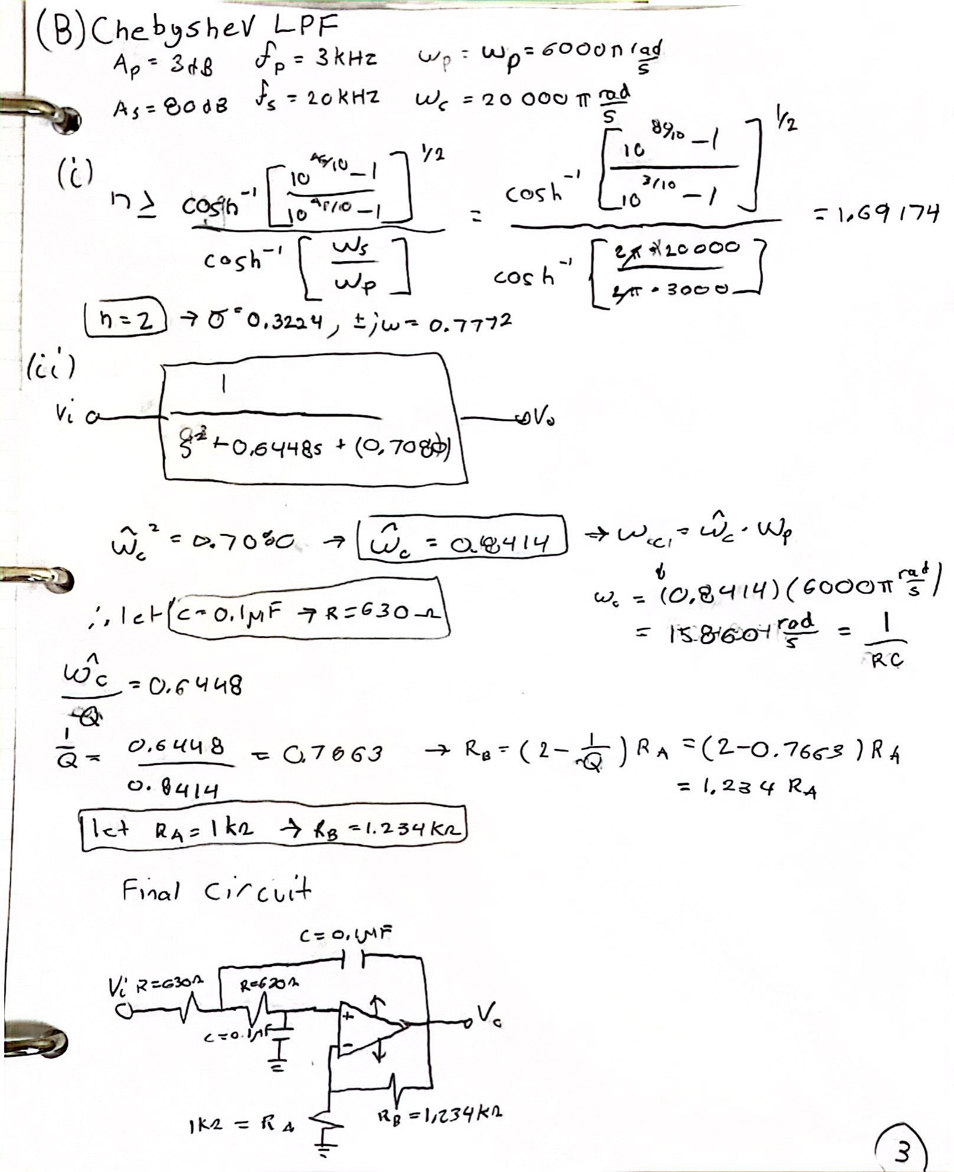

Multisim Section:

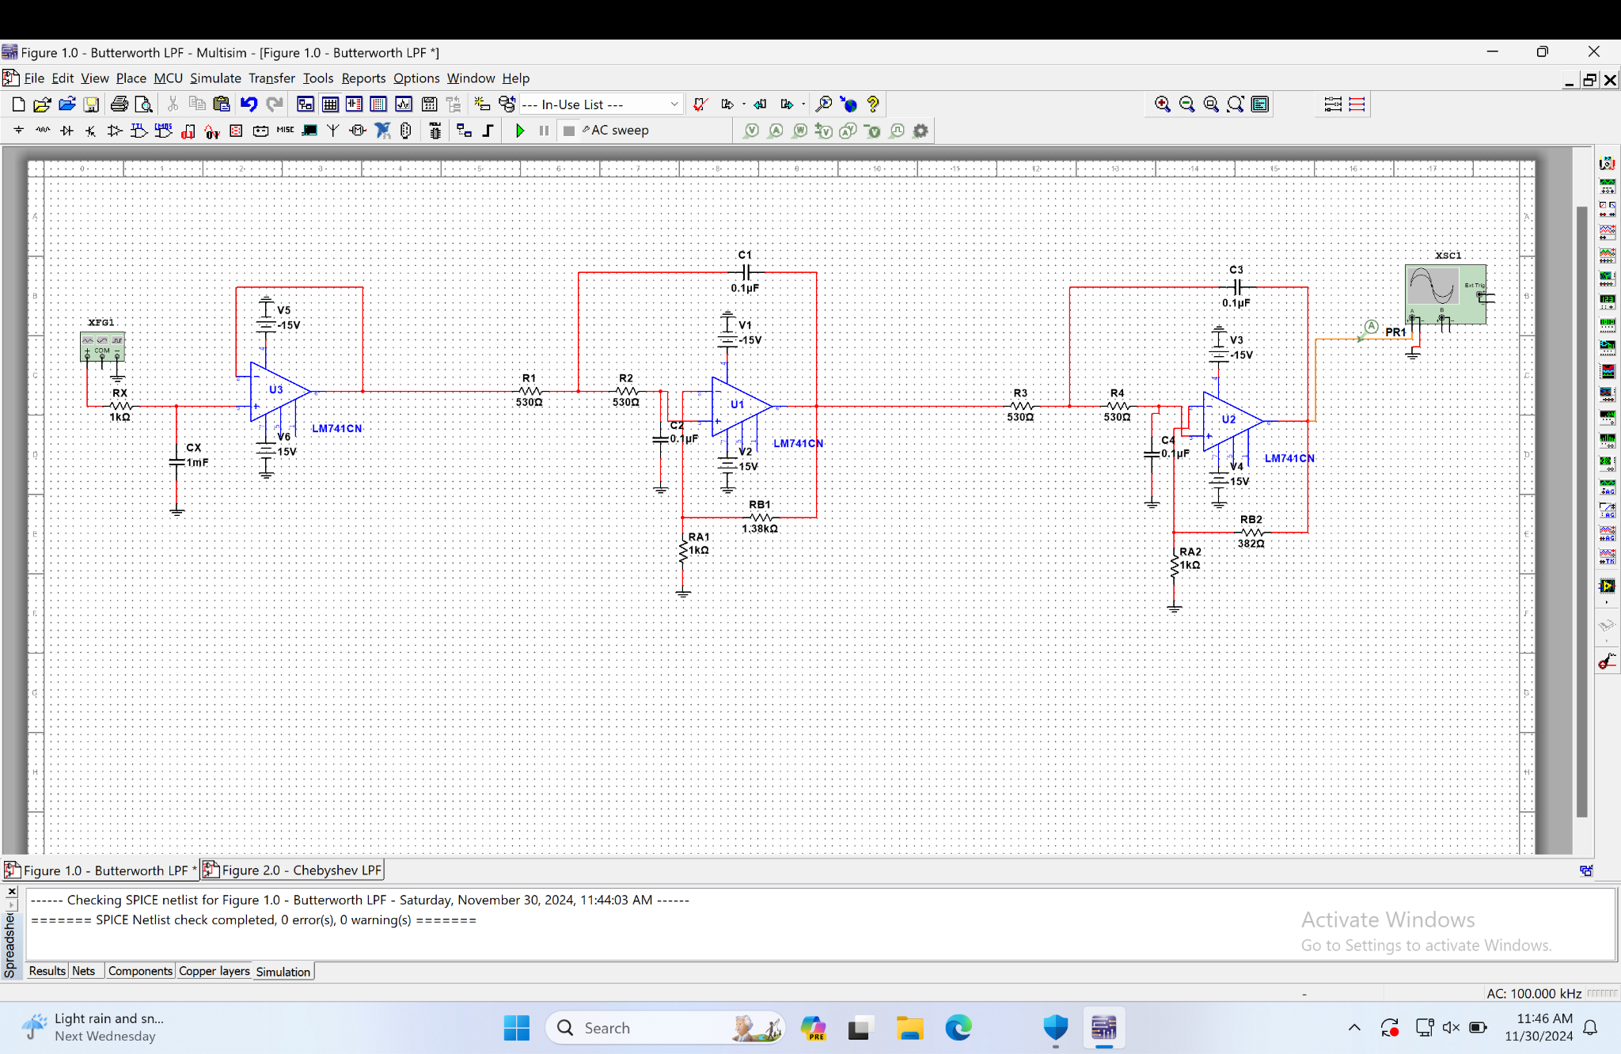
Figure 1.0: Butterworth LPF

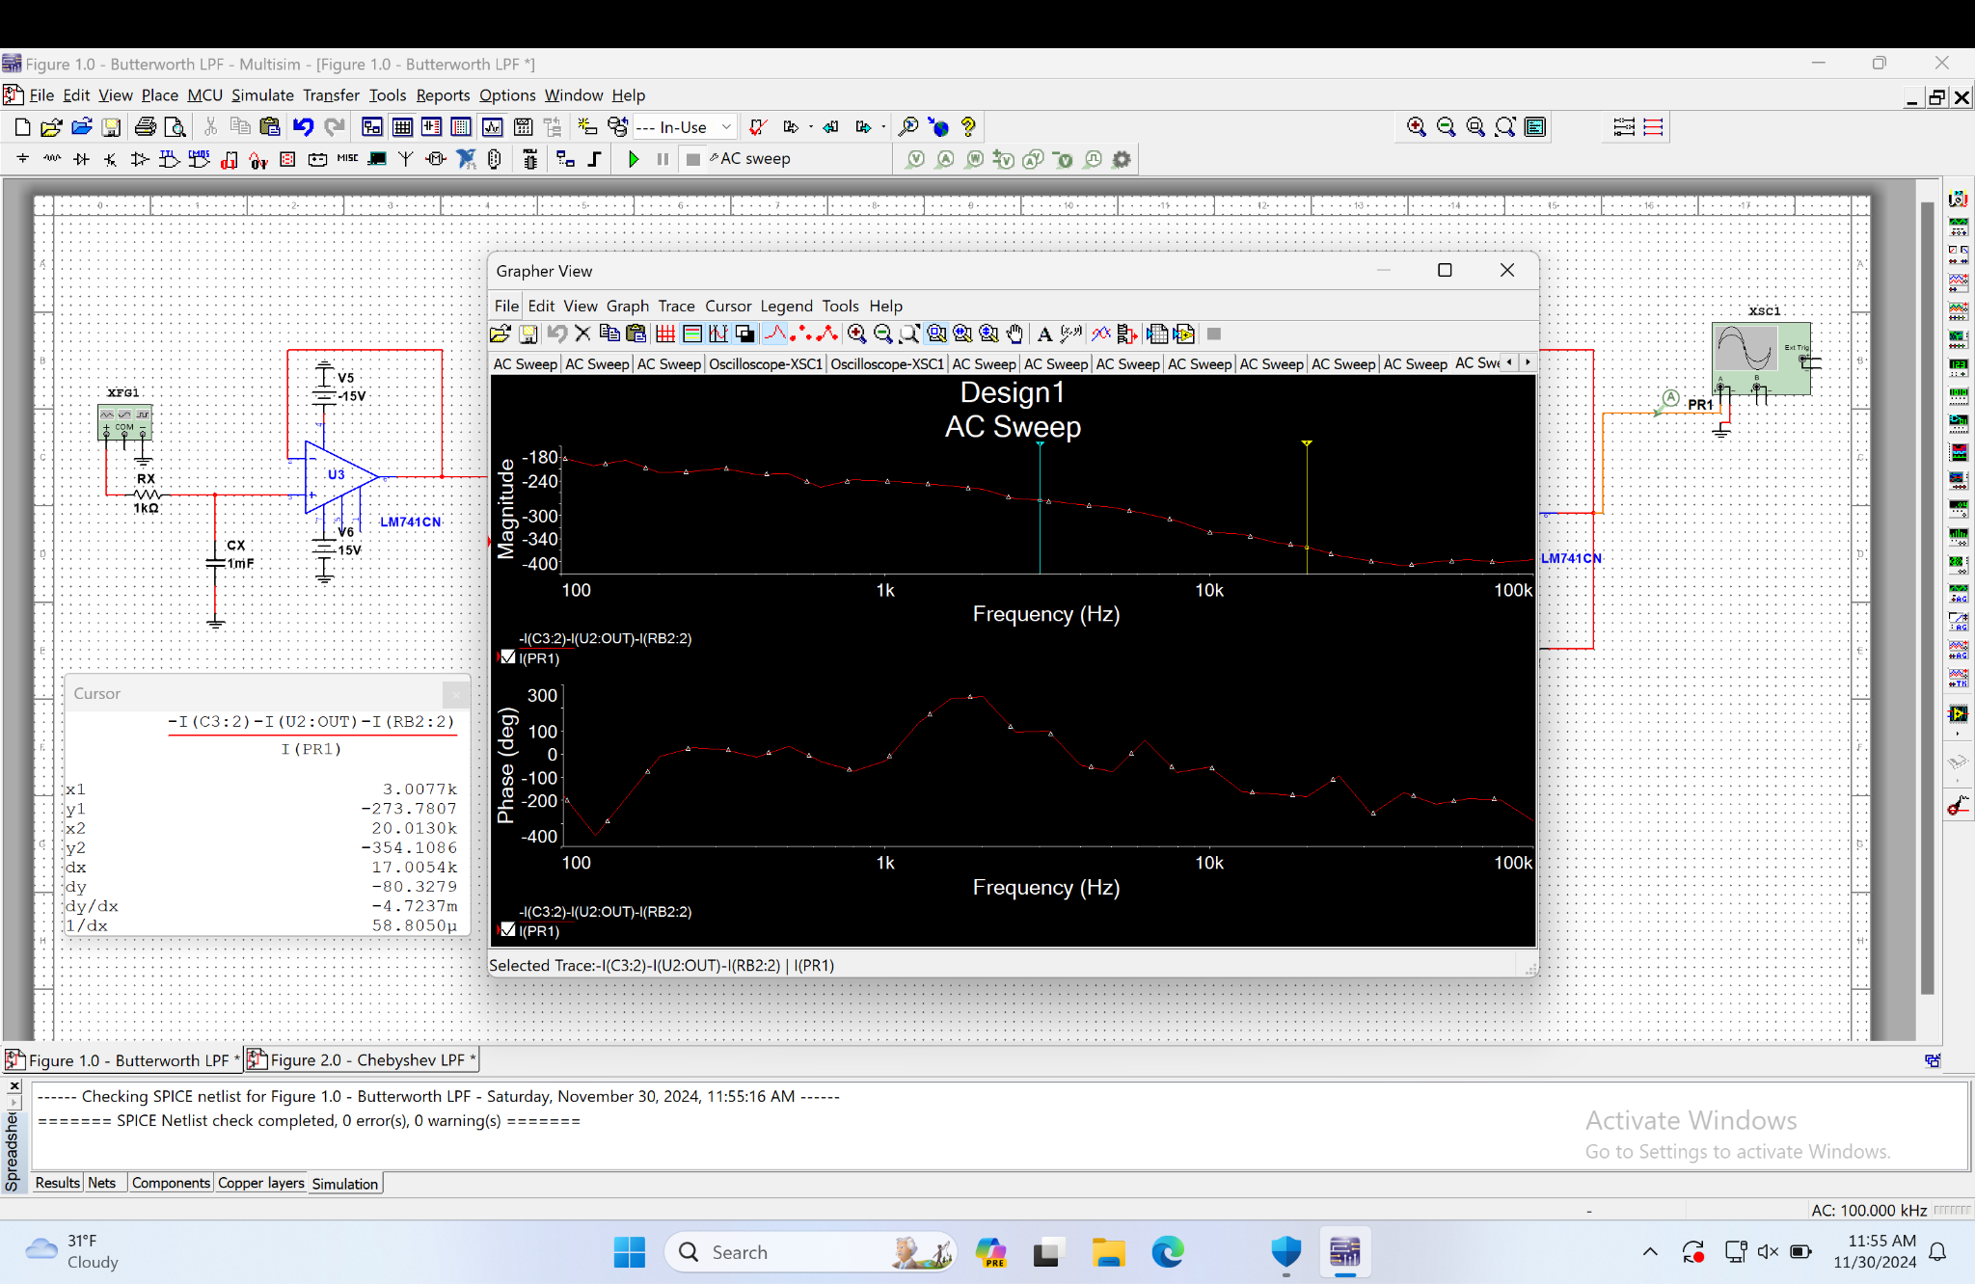
AC Sweep of Figure 1.0: Butterworth LPF

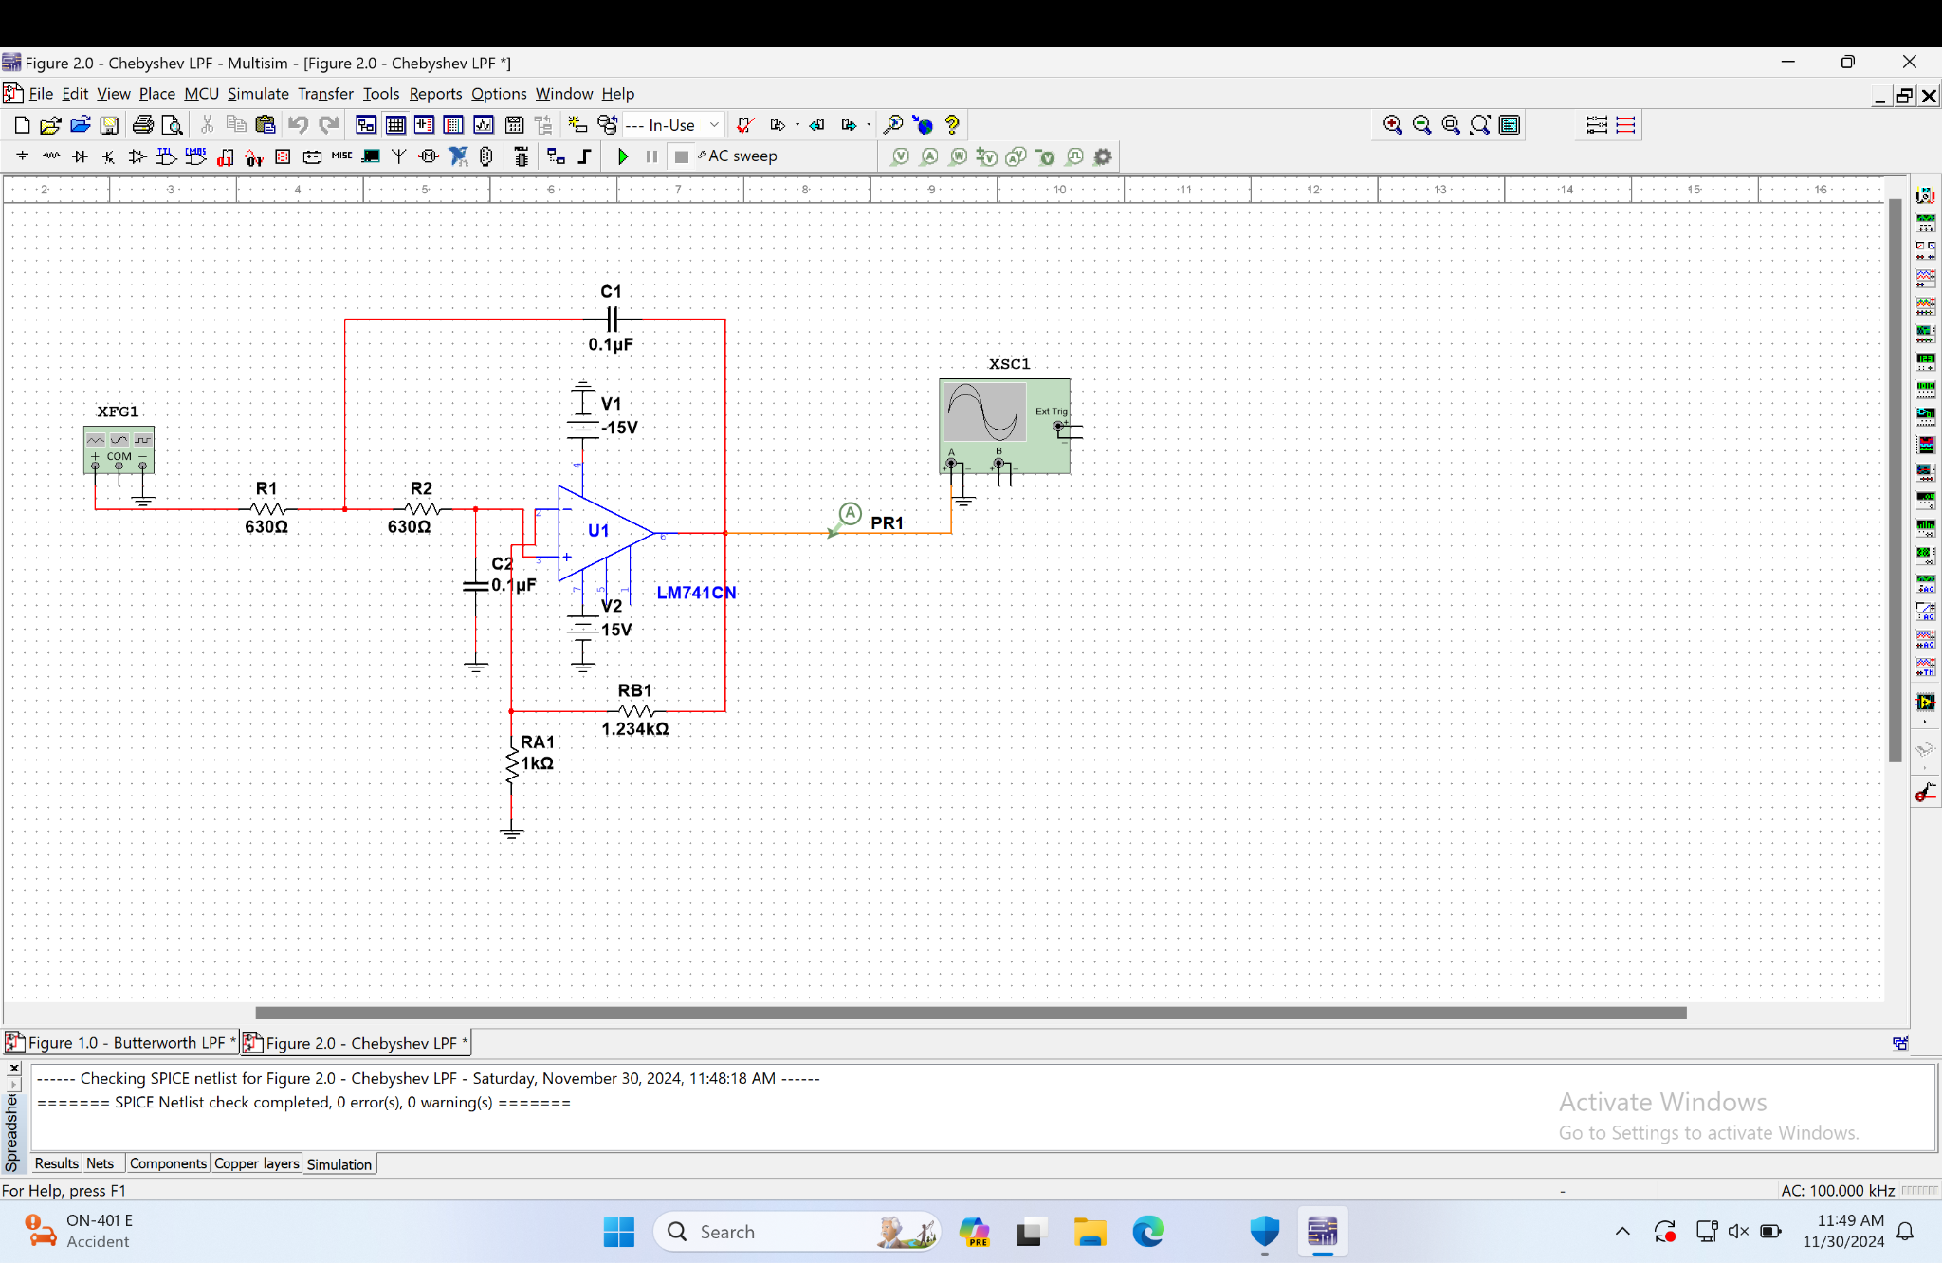
Figure 2.0: Chebyshev LPF

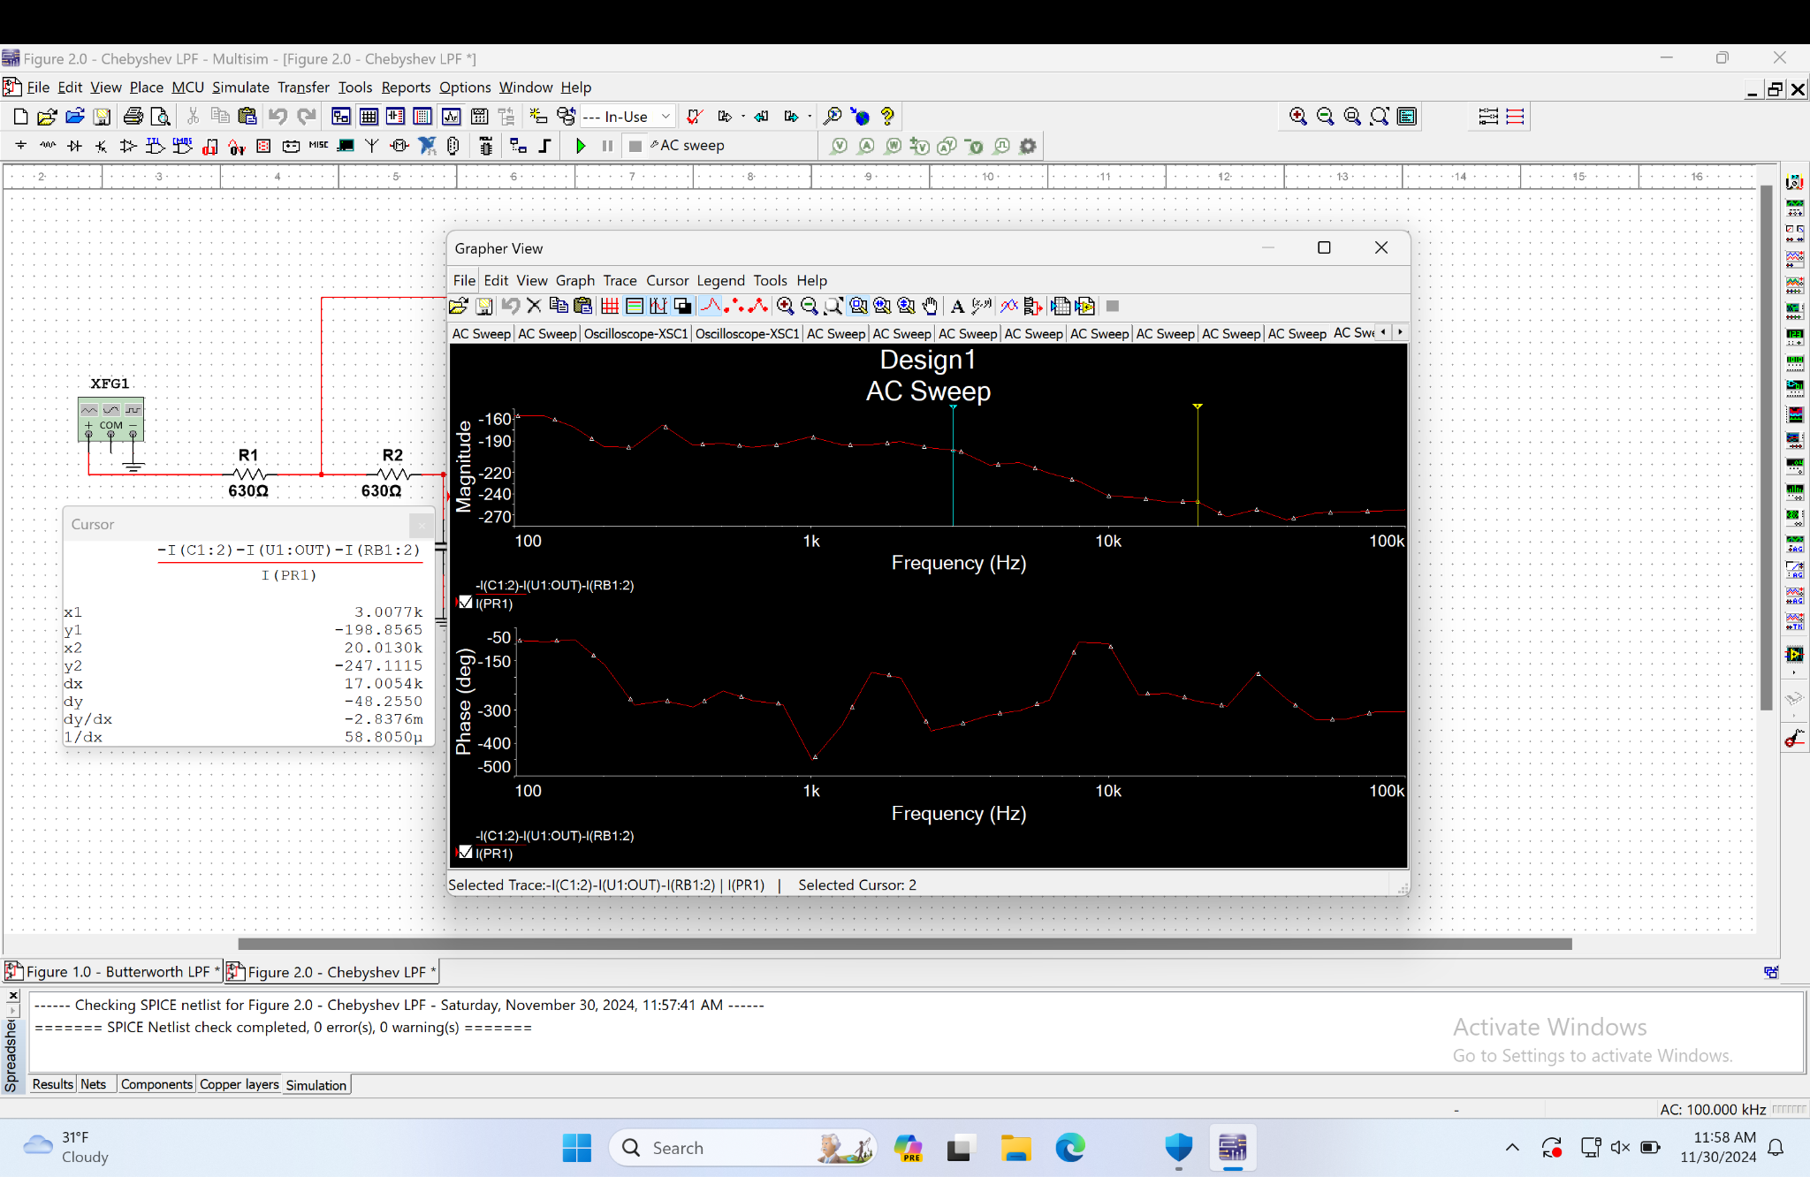
AC Sweep of Figure 2.0: Chebyshev LPF

 | Calculations |  | Simulations (Multisim)
LPF | Butterworth | Chebyshev | Butterworth | Chebyshev
A_{P} | 3dB | 3dB | -273.7807dB | -198.8565dB
$f_{p}$ | 3kHz | 3kHz | 3.0077kHz | 3.0077kHz
A_{S} | 82.730dB | 80dB | -354.1086dB | -247.1115dB
$f_{s}$ | 20kHz | 20kHz | 20.0130kHz | 20.0130kHz
Table 1.0: Summary of Pre-lab Calculations and Multisim Observations

